



TAZAMA SIMULATION MODULE
USER MANUAL

Version 1.0
17.06.2026
Document Information
Project | TAZAMA FRMS
Document Title | TAZAMA SIMULATION MODULE
Prepared by | SYEDA RUBA ZEHRA –BA @ PAYSYSLABS
Version Number | 1.0
Version Date | 17.06.2026

Document Revision History
Date | Author | Version | Change Reference
17.06.2026 | SYEDA RUBA ZEHRA | 1.0 | BASELINE VERSION SHARED WITH TAZAMA FOR REVIEW

Table of Contents
1. Getting Started with Simulation Module 5
1.1. What is Simulation Module? 5
1.2. Who Should Read This? 5
1.3. Prerequisites & Assumptions 5
2. How a Simulation Dataset is Built and a Simulation is Run 7
2.1. The Big Picture 7
2.2. Your End-to-End Journey 7
Step 1 – Select Rule and Primary TxTp 7
Step 2 – Configure fields for Context Data 8
Step 3 - Configure fields for Trigger Data 8
Step 4 – Configure Enrichment Table 8
Step 5 – Preview & Save 8
Step 6 – Run Simulation 8
3. Accessing the System 9
3.1. Logging In 9
3.2. Navigating the Application 9
3.1. Message Sampler Dashboard 10
3.1.1 Filtering and Searching Suites 11
3.1.2 The Suites Table 12
3.2. Creating a Simulation Suite 12
3.2.1 Rules and Details 12
3.2.2 TXTP Selection (Context Data Configuration) 14
3.2.3 Trigger Data 17
3.2.4 Enrichment Data 18
3.2.5 Preview and Save 19
3.2.6 Simulation Results 20
4. Appendices 21
4.1. Closing Note 21
4.2. Support and Escalation 22
4.3. Glossary 22

Getting Started with Simulation Module

What is Simulation Module?
The Simulation Module is a built-in testing environment within the Tazama Rule Studio that allows users to create synthetic transaction datasets, run them against a rule processor, and validate that the rule is producing the correct outputs. Rather than relying on manual setups or real production data, the module provides a governed and repeatable workspace where a rule can be tested in a controlled way, its results reviewed, and those results saved for future comparison.

Who Should Read This?
This manual is intended for two roles:
- Rule Editor are responsible for building and modifying rules within the Rule Studio. They use the Simulation Module to verify that a rule they have created or changed is calculating the correct output before it progresses further.
- Rule Approver are responsible for validating rule behavior against defined expectations. They use the Simulation Module to run test scenarios, review results, and confirm that a rule meets its intended purpose.
Both roles work through the same Simulation Module interface and follow the same steps described in this manual.

Prerequisites & Assumptions
Before using the Simulation Module, ensure the following are in place:
- You have an active Tazama Rule Studio account with either the Editor or Approver role assigned. If you are unsure of your role, contact your system administrator.
- The rule you intend to test has already been created in the Rule Studio and is available in the Rules Home list.
- The TXTP you intend to use must be available in the Connection Studio and in an approved status. This means DEMS is ready to ingest transaction payloads against that TXTP. Without this in place, the simulation suite cannot be established. Refer to the Connection Studio documentation for details on how to verify TXTP status.
This manual assumes the following:
- You are familiar with the rule you are testing — specifically, what transaction scenarios it is designed to detect and what output it is expected to produce. The Simulation Module does not guide you on what the rule should do; it provides the environment to verify that it does so correctly.
- The rule processor you intend to test is available as an image in your organization’s DockerHub namespace. It does not need to be actively running on the Rule Studio before you begin, but it must be available as a deployable image.

How a Simulation Dataset is Built and a Simulation is Run

The Big Picture
Before diving into individual steps, it helps to understand what is happening overall. When you use the Simulation Module, you are doing two things in sequence: first, you build a synthetic dataset that is shaped to test your rule; second, you run that dataset through the rule processor and review what comes out. The system handles the technical environment for you automatically in the background — you only interact with the configuration and results.
The diagram below shows the full end-to-end flow of the Simulation Module. This presents the steps you perform inside the Simulation Module and what happens automatically in the background.
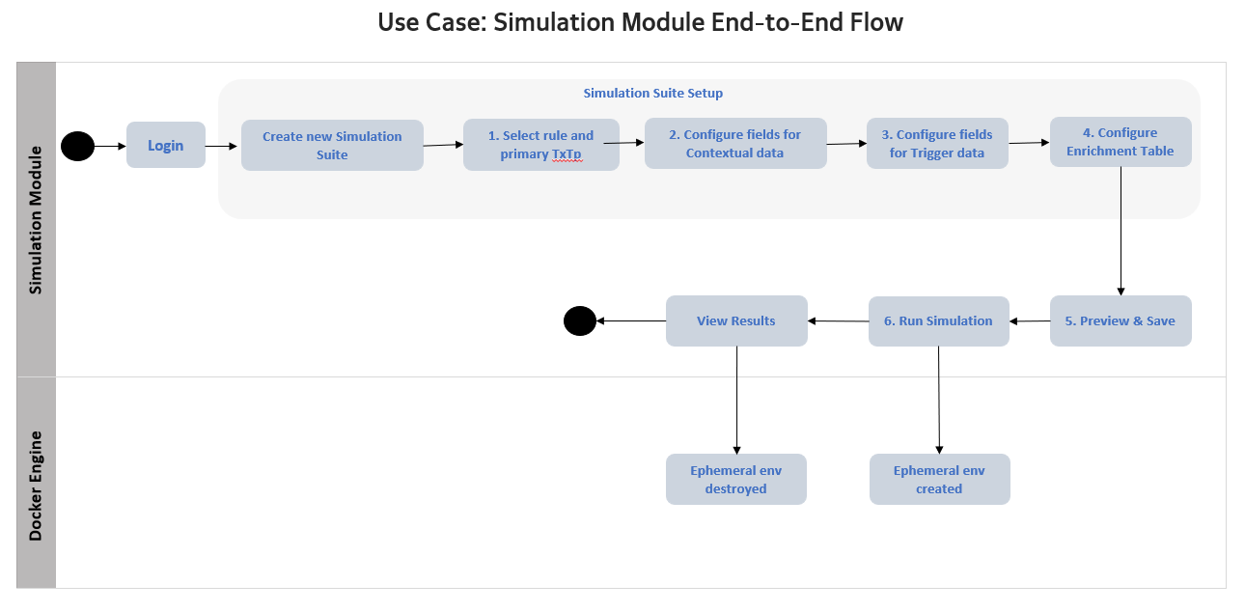

Your End-to-End Journey

Step 1 – Select Rule and Primary TxTp
You begin by creating a new simulation suite. This involves giving it a name, selecting the rule you want to test, and choosing the transaction payload type (TXTP) that the rule operates on. The TXTP defines the shape and format of the transaction messages your dataset will be built from.

Step 2 – Configure fields for Context Data
You configure the field-level conditions for your context data. Context data represents the historical transactions that exist in the system before your trigger transaction arrives. You control what values, ranges, and patterns these historical records contain so that they set up the exact scenario your rule needs to evaluate.

Step 3 - Configure fields for Trigger Data
You configure the trigger transaction — the live incoming message that the rule processor will actually evaluate against the context data you defined in Step 2. Together, Steps 2 and 3 form the complete synthetic dataset for your test.

Step 4 – Configure Enrichment Table
For rules that require reference data — such as sanctions lists or AML watchlists — you can supply that supplementary data here. This step is only applicable to rules that need to check against external reference information. If your rule does not require this, you can skip this step entirely.

Step 5 – Preview & Save
Before running the simulation, you are shown a preview of the dataset you have configured. Once you are satisfied, you save it. This saved dataset becomes a reusable simulation suite that can be run again in the future without needing to reconfigure everything from scratch.

Step 6 – Run Simulation
You trigger the simulation run. The system automatically spins up a temporary testing environment in the background, executes the rule processor against your dataset, and returns the results.

Accessing the System

The Simulation Module is accessible to users with the Editor or Approver role. These roles are assigned by your system administrator. If you are unsure of your role, check the top-right corner of the screen after logging in — your role is displayed alongside your email address. If you cannot see the Simulation Module in the sidebar after logging in, your account may not have the required role assigned. Contact your system administrator.

Logging In
To access the Tazama Rule Studio, open your browser and navigate to the application URL provided by your system administrator. You will be presented with the login screen.
Steps:
- Enter your registered email address in the Email Address field.
- Enter your password in the Password field.
- Click the Login button.
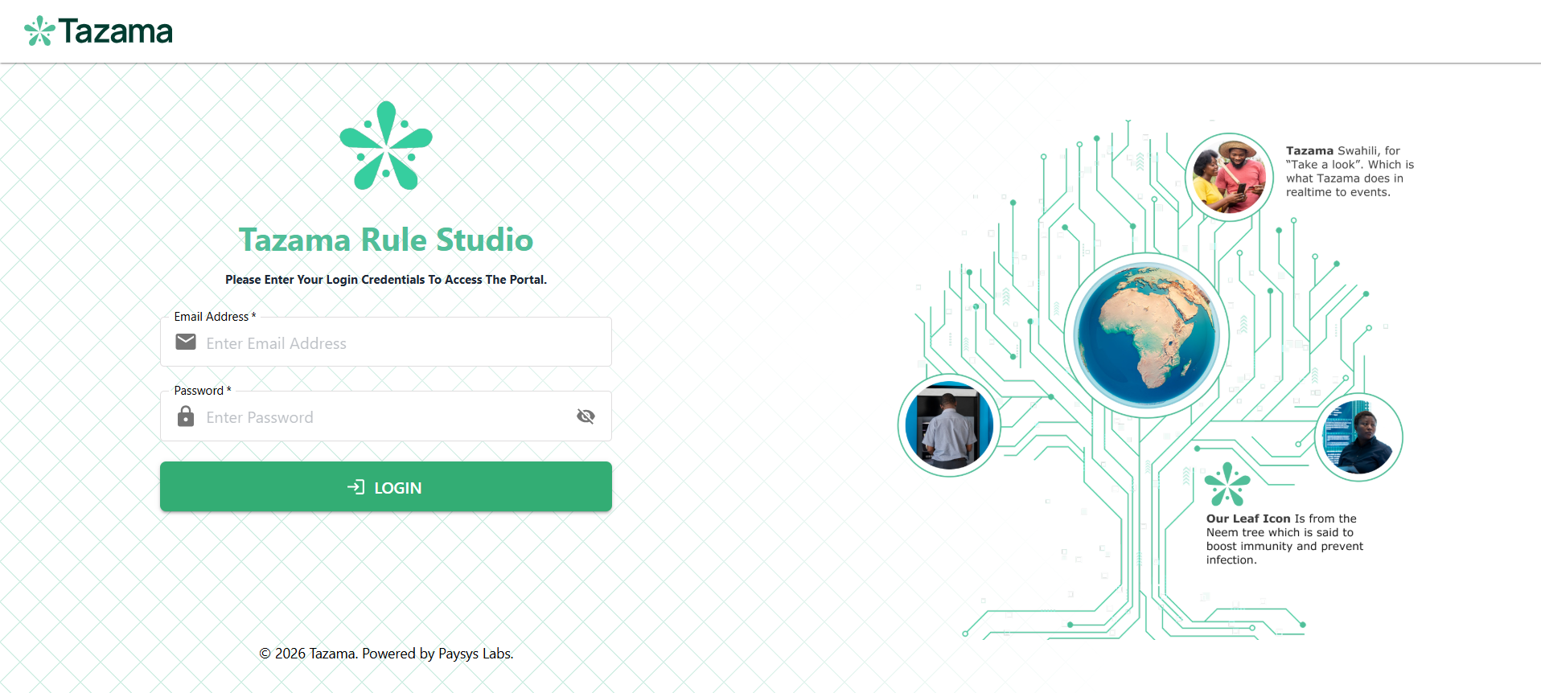

Navigating the Application
After logging in, you will land on the Rules Home page. The left-hand sidebar is your primary navigation and contains two sections:
- Home — the Rules Home page, where all rules created in the system are listed.
- Sim Studio — the Simulation Module, where you create and manage simulation suites and generate synthetic test data.
For this manual, all work is done within Sim Studio. The rules listed in TRS are the same rules you will associate with your simulation suites.
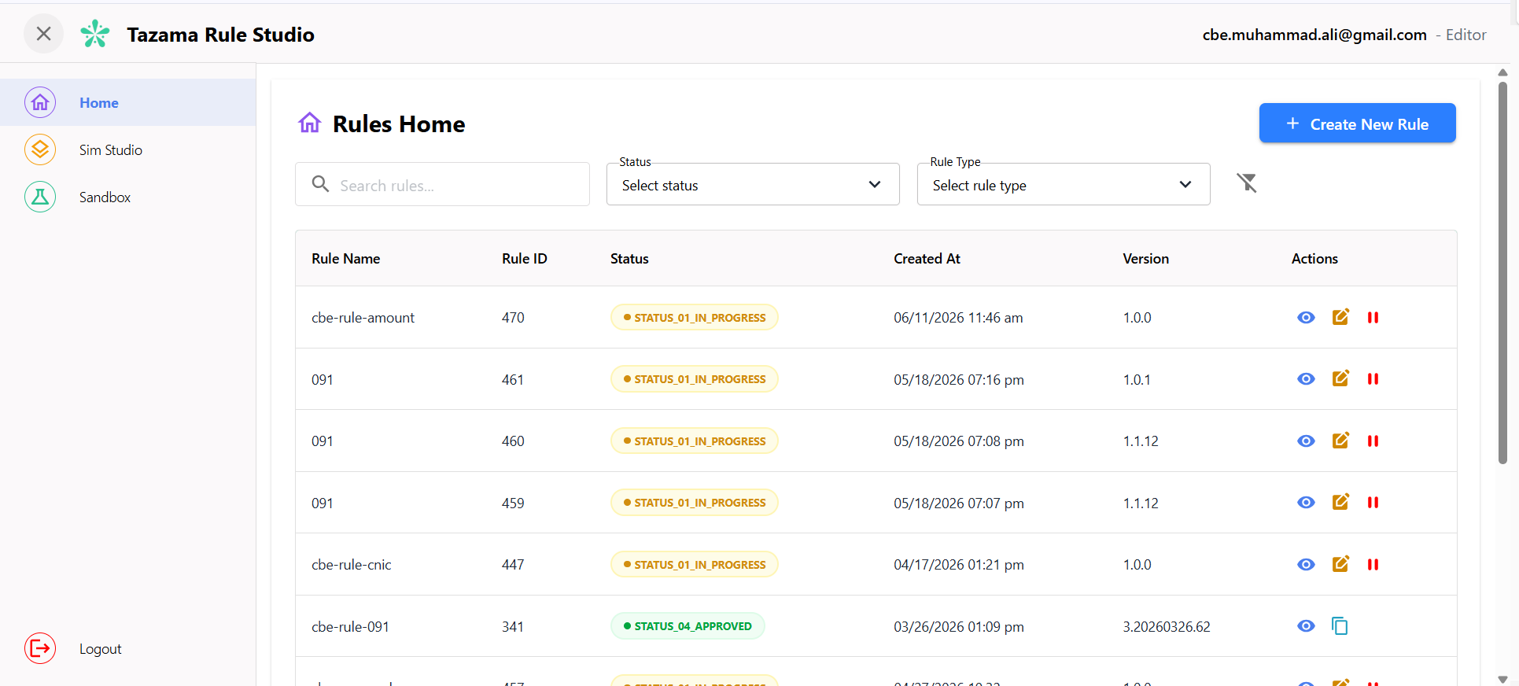
Click Sim Studio in the sidebar to open the Message Sampler. This is the starting point for all simulation activity.

Message Sampler Dashboard
At the top of the page you will see a summary row with four tiles:
- Total Suites — the total number of simulation suites that have been created in the system.
- Ready for Re-run — suites that have been run at least once and can be re-executed against the same dataset.
- Draft Suites — suites that are currently being configured and have not yet been run.
- Latest Iteration — the date of the most recently executed simulation run across all suites.
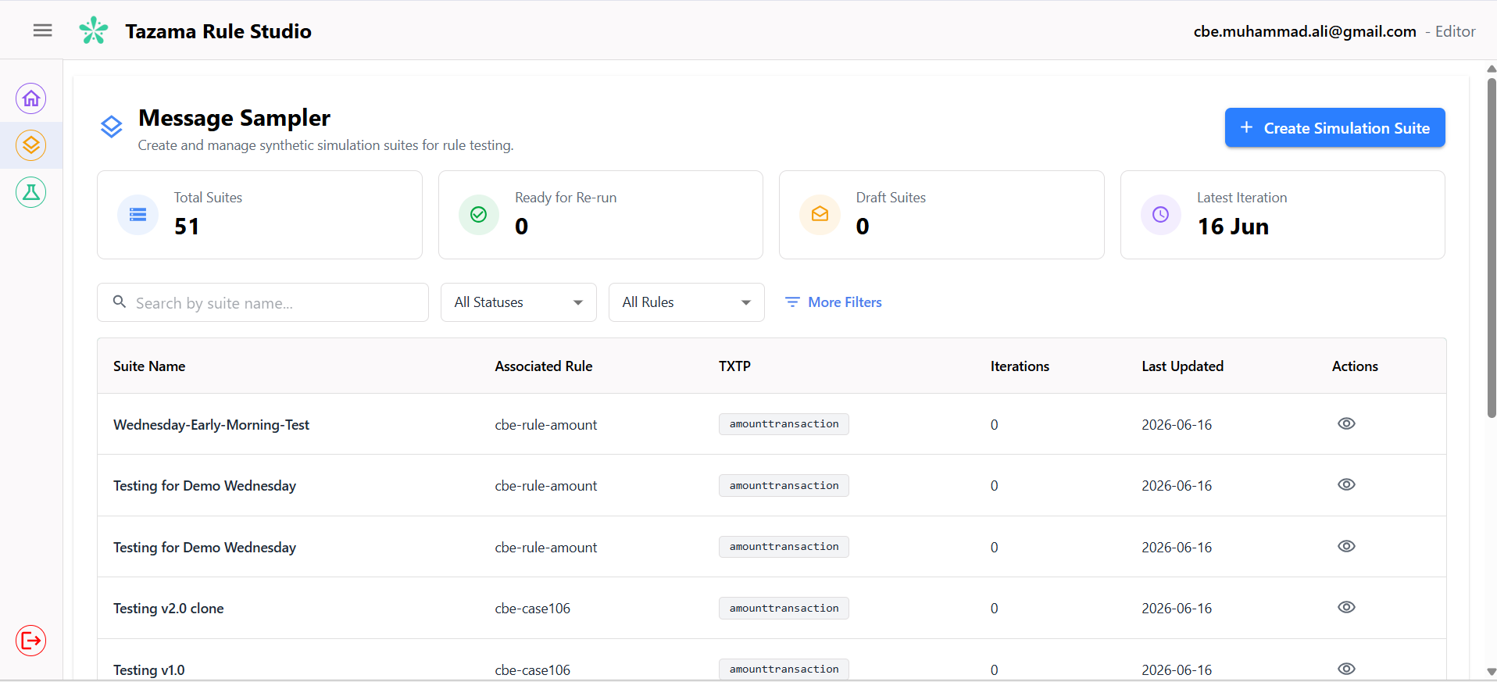
What is a simulation suite? A simulation suite is a named container that holds your synthetic test dataset and its configuration. It is associated with a specific rule and a specific transaction payload type (TXTP). Think of it as a saved test case — everything the system needs to run a test against a rule processor is stored inside the suite.

Filtering and Searching Suites
Below the summary tiles, you will find a search bar and filter controls.
- Use the search bar to find a suite by name.
- Use the All Statuses dropdown to filter suites by their current status:
  - Draft — the suite is still being configured.
  - Running — a simulation is currently in progress for this suite.
  - Completed — the simulation has been run successfully and results are available.
  - Failed — the simulation stopped due to an error or interruption.
- Use the All Rules dropdown to filter suites by the rule they are associated with.
- Click More Filters to access additional filters, including transaction type (TXTP) and the date range within which the suite was created.

The Suites Table
The table shows the lists of all existing simulation suites with the following columns:
- Suite Name — the name given to the suite when it was created.
- Associated Rule — the rule processor this suite is designed to test.
- TXTP — the transaction payload type used in this suite.
- Iterations — the number of times this suite has been run.
- Last Updated — the date the suite was last modified or run.
- Actions — the eye icon allows you to view the suite details.

Creating a Simulation Suite
To begin, click the + Create Simulation Suite button on the Message Sampler dashboard. This opens the six-step suite creation wizard. The tab bar at the top of the screen shows all six steps: Rule & Details, TXTP Selection, Trigger Data, Enrichment Data, Preview & Save, and Simulation Results.

Rules and Details
- Enter a name in the Simulation Suite Name field. Choose a name that clearly identifies what this suite is testing — for example, the rule name combined with the scenario.
- Enter a description in the Description field. Describe the purpose of this suite — what scenario you are testing and what you expect the rule to produce.
- Select the rule you want to test from the Associated Rule dropdown. The rules listed here are the rule currently available in the DockerHub.
- Once a rule is selected, choose the appropriate version from the Rule Version dropdown. If multiple versions exist, select the version that corresponds to the rule code you are testing.
- Select the transaction payload type from the TXTP dropdown. The TXTP defines the format and structure of the transaction messages your dataset will be built from. The available options are fetched from the TCS.
- Select the corresponding TXTP version from the Version dropdown.
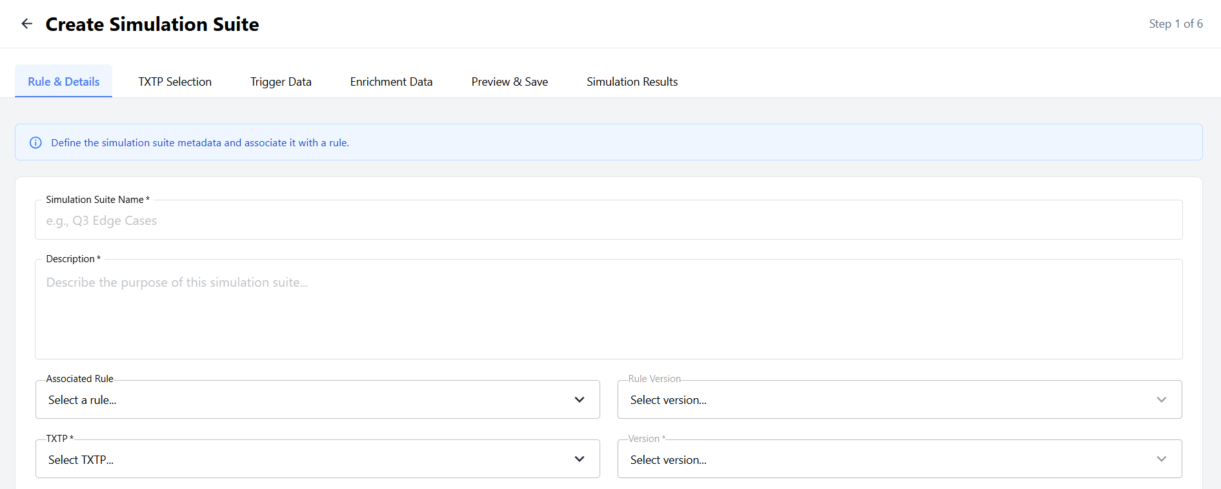
- Enter the rule configuration in the Rule Config (JSON) field. This must be a valid JSON object that matches the configuration the rule processor expects to run with.
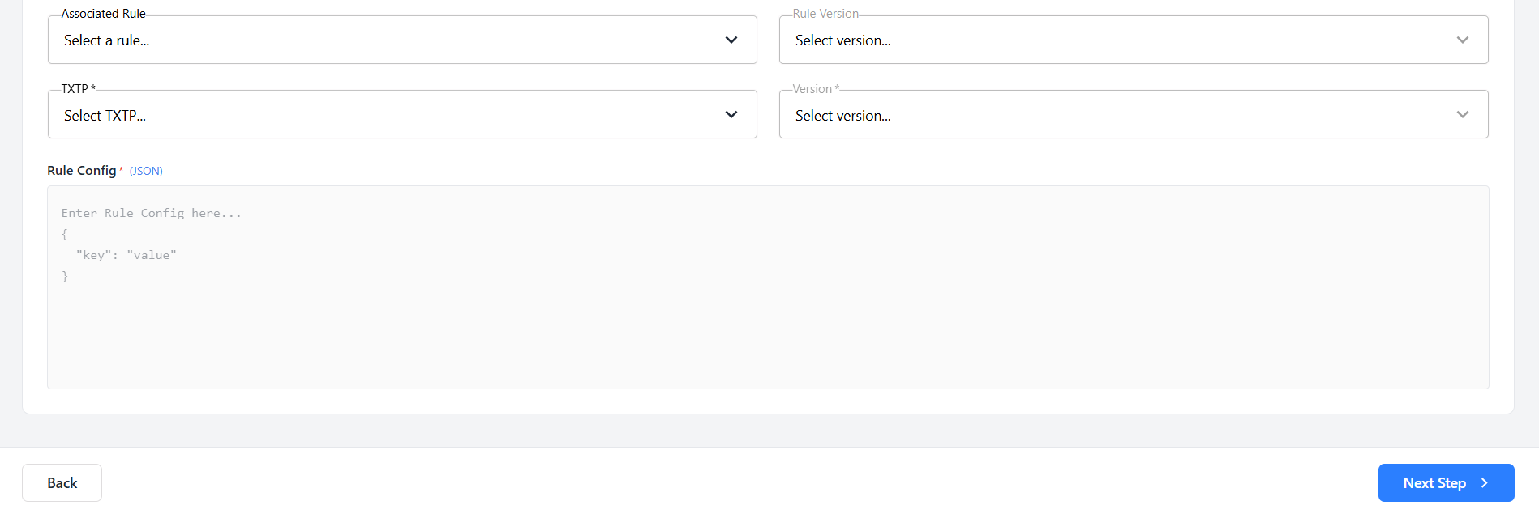
- Click Next Step to proceed to Step 2.
What is a Rule Config and where do I get it? The Rule Config is a JSON object that defines the parameters the rule processor uses when evaluating a transaction. This is a required field and the simulation cannot proceed without it. You are expected to have this configuration ready before starting the suite creation. If you are unsure what the correct rule config is for the rule you are testing, consult the rule developer or retrieve it from the Rule Studio before beginning this step.

TXTP Selection (Context Data Configuration)
This step is where you configure the context data — the historical transaction records that the rule processor will look back on when it evaluates the trigger message. If the rule you are testing checks a debtor's transaction history over the past 30 or 90 days, for example, this is where you define what that history looks like.
Understanding the Context Data Block
Each TXTP block displays:
- The TXTP name and version — for example, amounttransaction v1.0.0
- A Messages field — the number of historical transaction records that will be generated for this dataset. The default value is 100.
- A Remove button — to remove the context data block entirely if your rule does not require transaction history
- A Field Configuration table — where you define how each field in the transaction payload should be populated
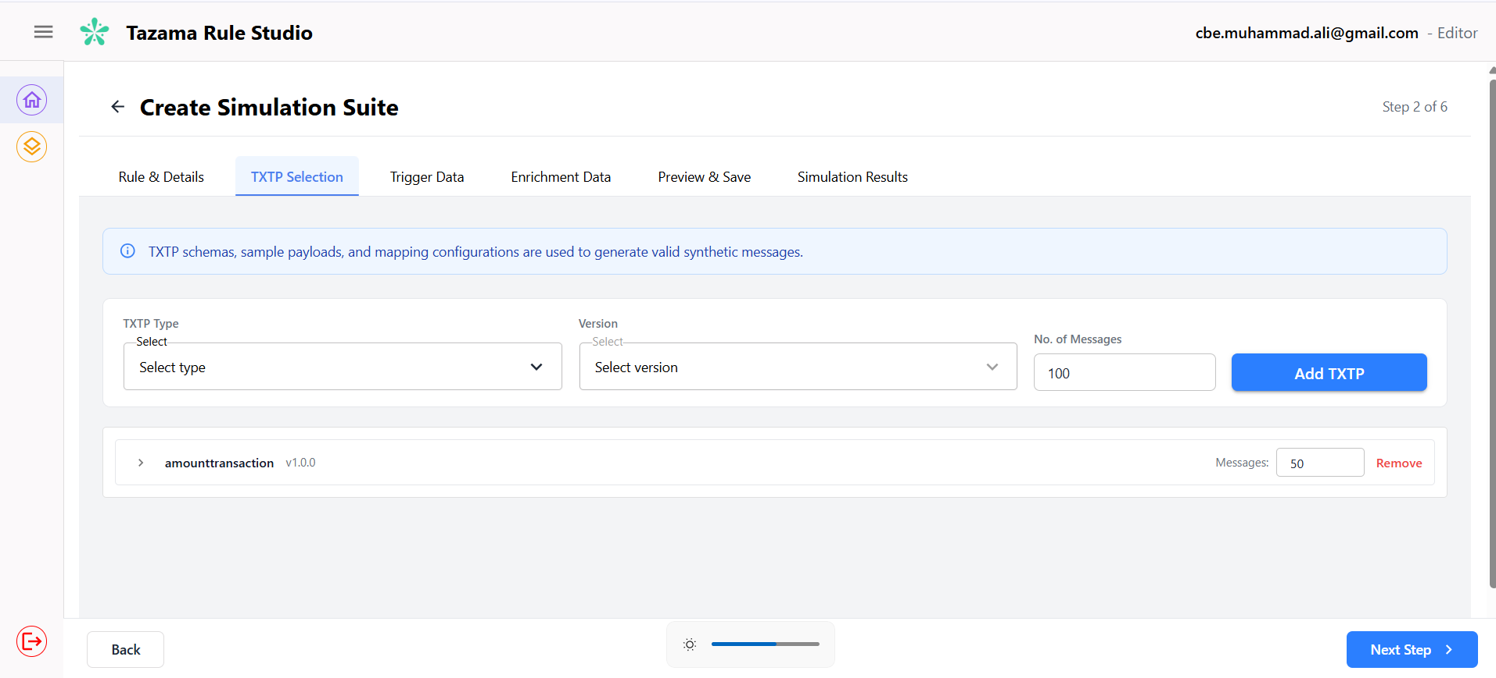
What happens if you remove the context data block? If you remove the TXTP block, no historical transaction records will be generated. The rule processor will treat every trigger transaction as if it is the first time it has seen activity between those parties. Only remove this block if the rule you are testing is specifically designed to handle first-time transactions with no prior history

Configuring Fields
The Field Configuration table lists every field available in the selected TXTP. For each field, you choose an Action that tells the system how to populate that field when generating the synthetic records.
The available actions are:
- Use Sample Value — the field is populated with the sample value defined in the TCS configuration for that TXTP. Use this for fields that are not relevant to the rule you are testing and where the exact value does not matter.
- Set Static Value — the field is populated with a specific value or values that you define. You can enter a single value, or enter multiple values separated by commas — the system will distribute these values across the generated messages. Use this when you need precise control over what a field contains, for example, setting the amount field to exactly 5000.
- Use Range — the field is populated with values randomized within a minimum and maximum range that you specify. Use this when you want variation in a field but within controlled boundaries, for example, amounts between 500 and 10,000.
- Skip Field — the field is omitted from the generated message payload entirely. Use this for fields that are marked as optional in the TXTP schema, allowing you to test scenarios where that field is absent. Do not skip fields that are required by the schema or the rule processor, as this will cause the simulation to fail.
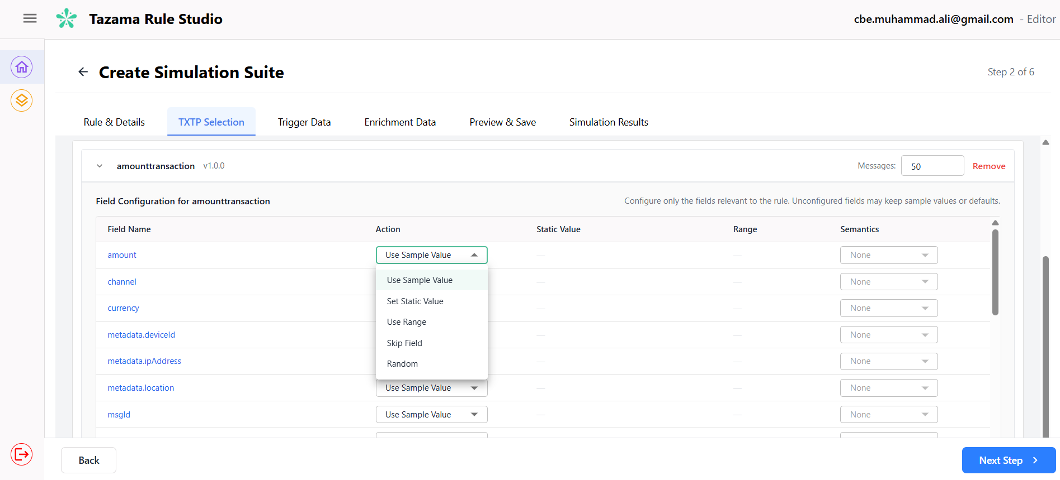
- Random — the field is populated with a randomly generated value. When this action is selected, the Semantics dropdown becomes available.
  - Semantics: When you select Random, then Semantics allows you to tell the system what kind of value to generate so the output is realistic and readable rather than a meaningless string of characters. For example, setting Semantics to Email on an email field will generate a properly formatted email address. Setting it to Timestamp will generate a valid date and time value. Available semantics options include: Name, Country, Country Code, BIC, Currency, Email, Address, and Timestamp.
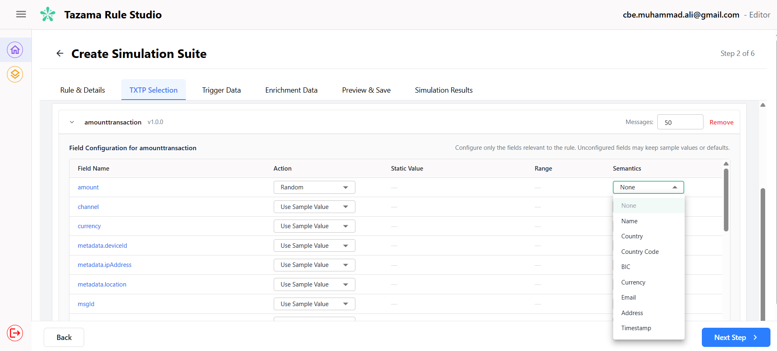
Important: You are responsible for knowing which fields matter for the rule you are testing and configuring them accordingly. The system does not validate whether your field configuration is appropriate for the rule — it will generate exactly what you configure. If a required field is skipped or populated with an incompatible value, the rule processor may fail during the simulation run. If you are unsure which fields are critical, review the rule definition in the Rule Studio before proceeding.

Linked Transaction Pairs
Some rules require that certain transaction messages in the context data are linked to each other — specifically, that a pacs.002 payment status message is associated with its originating pacs.008 credit transfer message. This linkage is established by sharing a common identifier between the two messages, typically the End-to-End ID.
When you add a pacs.002 TXTP to the context data, the system will display a Linked Transaction Pair section beneath it, showing both the pacs.008 and pacs.002 blocks grouped together.
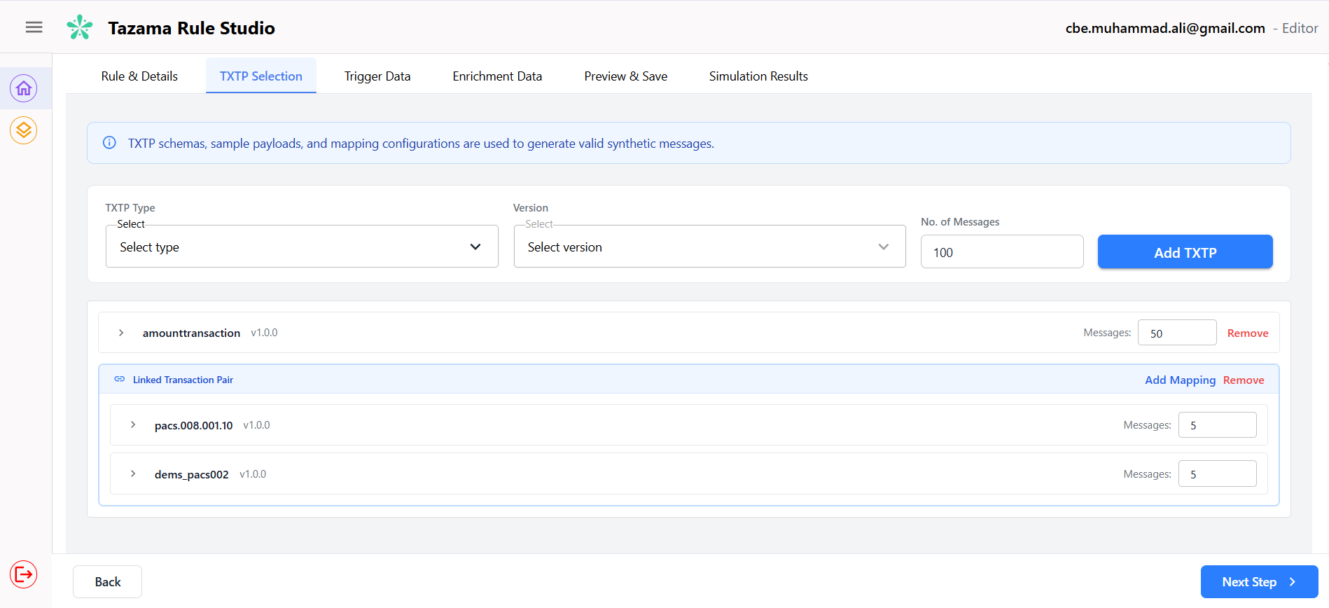
To set up the field mapping that creates the link:
- Click Add Mapping on the Linked Transaction Pair section. The Field Mapping modal will open.
- The modal displays two panels — the pacs.008 fields on the left and the pacs.002 fields on the right, with a Mapped Pairs column in the centre.
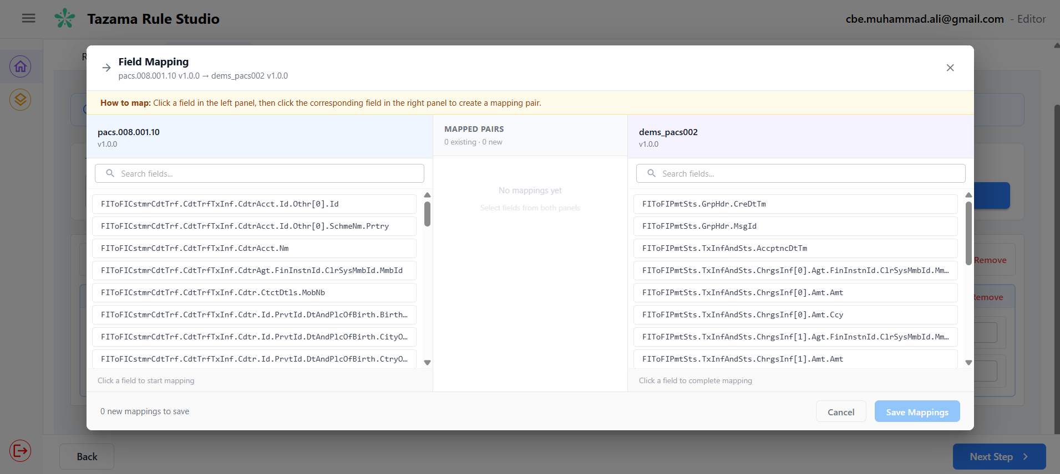
- Click a field in the left panel to select it — for example, FIToFICstmrCdtTrf.CdtTrfTxInf.PmtId.EndToEndId on the pacs.008 side.
- Click the corresponding field in the right panel to complete the pair — for example, FIToFIPmtSts.TxInfAndSts.OrgnlEndToEndId on the pacs.002 side.
- The mapping pair will appear in the Mapped Pairs column at the centre.
- Repeat for any additional fields that need to be matched between the two message types.
- Click Save Mappings to apply. Click Cancel to discard.
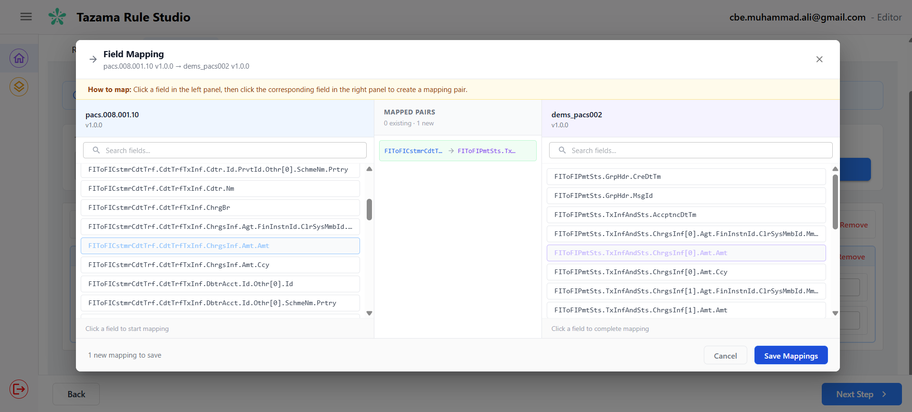
Why does this matter? If your rule requires linked transaction pairs and you do not set up the field mapping correctly, the rule processor will not be able to associate the pacs.002 message with its corresponding pacs.008. This will produce incorrect results and may cause the simulation to fail entirely. If you are unsure whether your rule requires linked transaction pairs, check the rule definition before proceeding.

Steps
- Review the TXTP block that has been pre-loaded from your Step 1 selection.
- Set the Messages count to the number of historical records you want to generate.
- For each field in the Field Configuration table, select the appropriate Action from the dropdown.
- If you selected Set Static Value, enter your value or comma-separated values in the Static Value column.
- If you selected Use Range, enter the minimum and maximum values in the Range column.
- If you selected Random, optionally select a Semantics type from the dropdown to ensure the generated value is realistic for that field type.
- If your rule requires additional transaction types in the history, select the TXTP type and version from the dropdowns at the top and click Add TXTP. Configure the fields for the new block.
- If your rule requires linked transaction pairs, click Add Mapping on the Linked Transaction Pair section and set up the field mappings as described above.
- Once all relevant fields and mappings are configured, click Next Step to proceed to Step 3.

Trigger Data
This step is where you configure the trigger transaction — the live incoming message that will be submitted to the rule processor during the simulation. If the context data you configured in Step 2 represents the background history, the trigger transaction is the foreground event that the rule processor actually evaluates against that history.
The TXTP you selected in Step 1 is pre-loaded here and cannot be changed. The default number of messages is set to 1, meaning a single trigger transaction will be submitted to the rule processor. You can increase this if your test scenario requires multiple trigger transactions to be evaluated. If the TXTP has a linked transaction defined in the Connection Studio, that linked transaction will also appear on this screen — however, it will not be submitted to the rule processor as a trigger. Instead, it will be treated as context for the primary transaction.
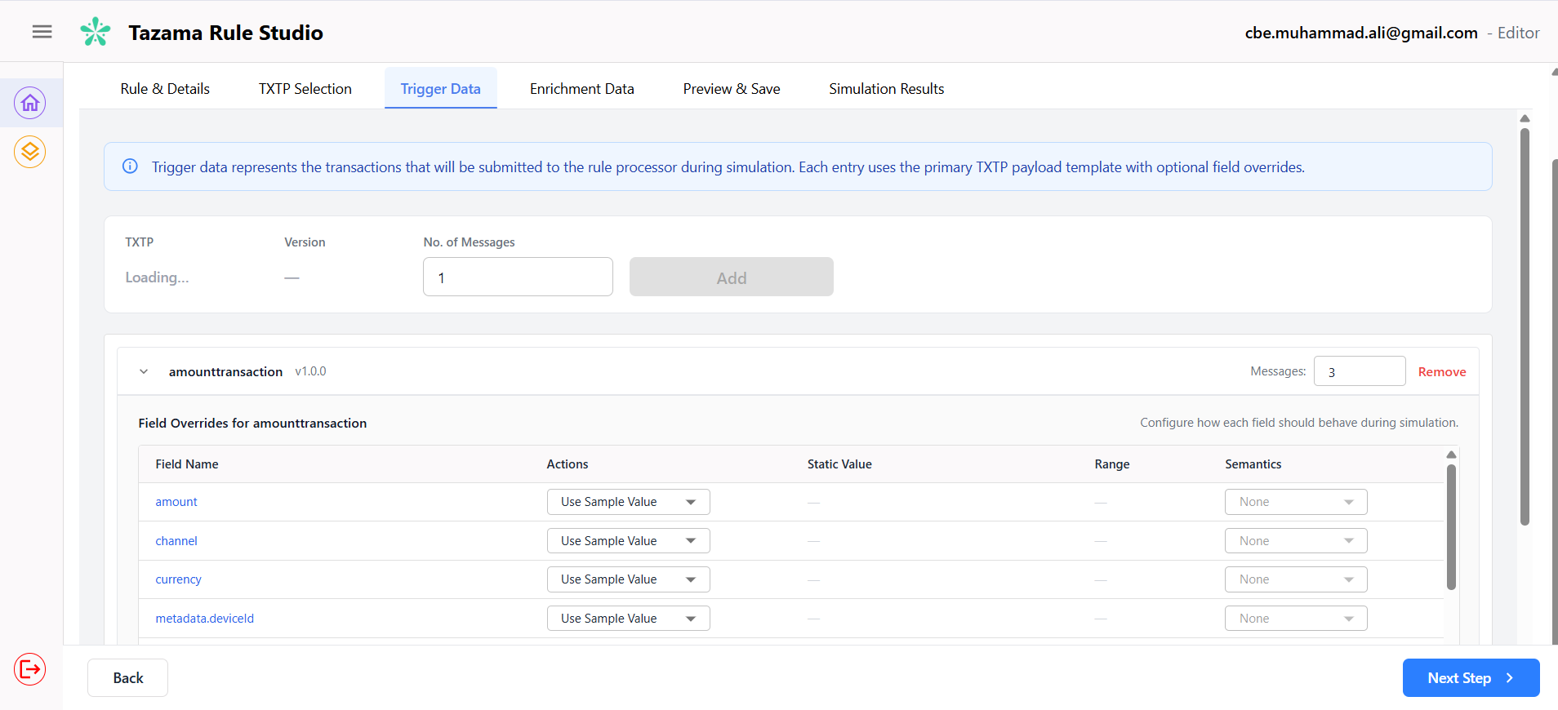
Steps:
- Review the TXTP block that has been pre-loaded from your Step 1 selection.
- Set the No. of Messages to the number of trigger transactions you want to submit. In most cases this will be 1.
- Click Add to confirm the trigger message block.
- In the Field Overrides table, configure only the fields relevant to your test scenario. Leave all other fields set to Use Sample Value.
- If you selected Set Static Value, enter your value or comma-separated values in the Static Value column.
- If you selected Use Range, enter the minimum and maximum values in the Range column.
- If you selected Random, optionally select a Semantics type from the dropdown.
- Once you are satisfied with the trigger configuration, click Next Step to proceed to Step 4.
Important: The same caution applies here as in Step 2. You are responsible for knowing which fields the rule processor requires in the trigger message. Skipping a required field or setting it to an incompatible value may cause the rule processor to fail during the simulation run.

Enrichment Data
This step is optional. If the rule you are testing does not require any external reference data lookups, click Next Step to skip this step entirely and proceed to Step 5.
For rules that do require enrichment data — for example, a rule that checks a sender's name against a sanctions list, or a rule that looks up an account balance from a reference table — this step is where you define that supplementary data and load it into the sandbox environment.
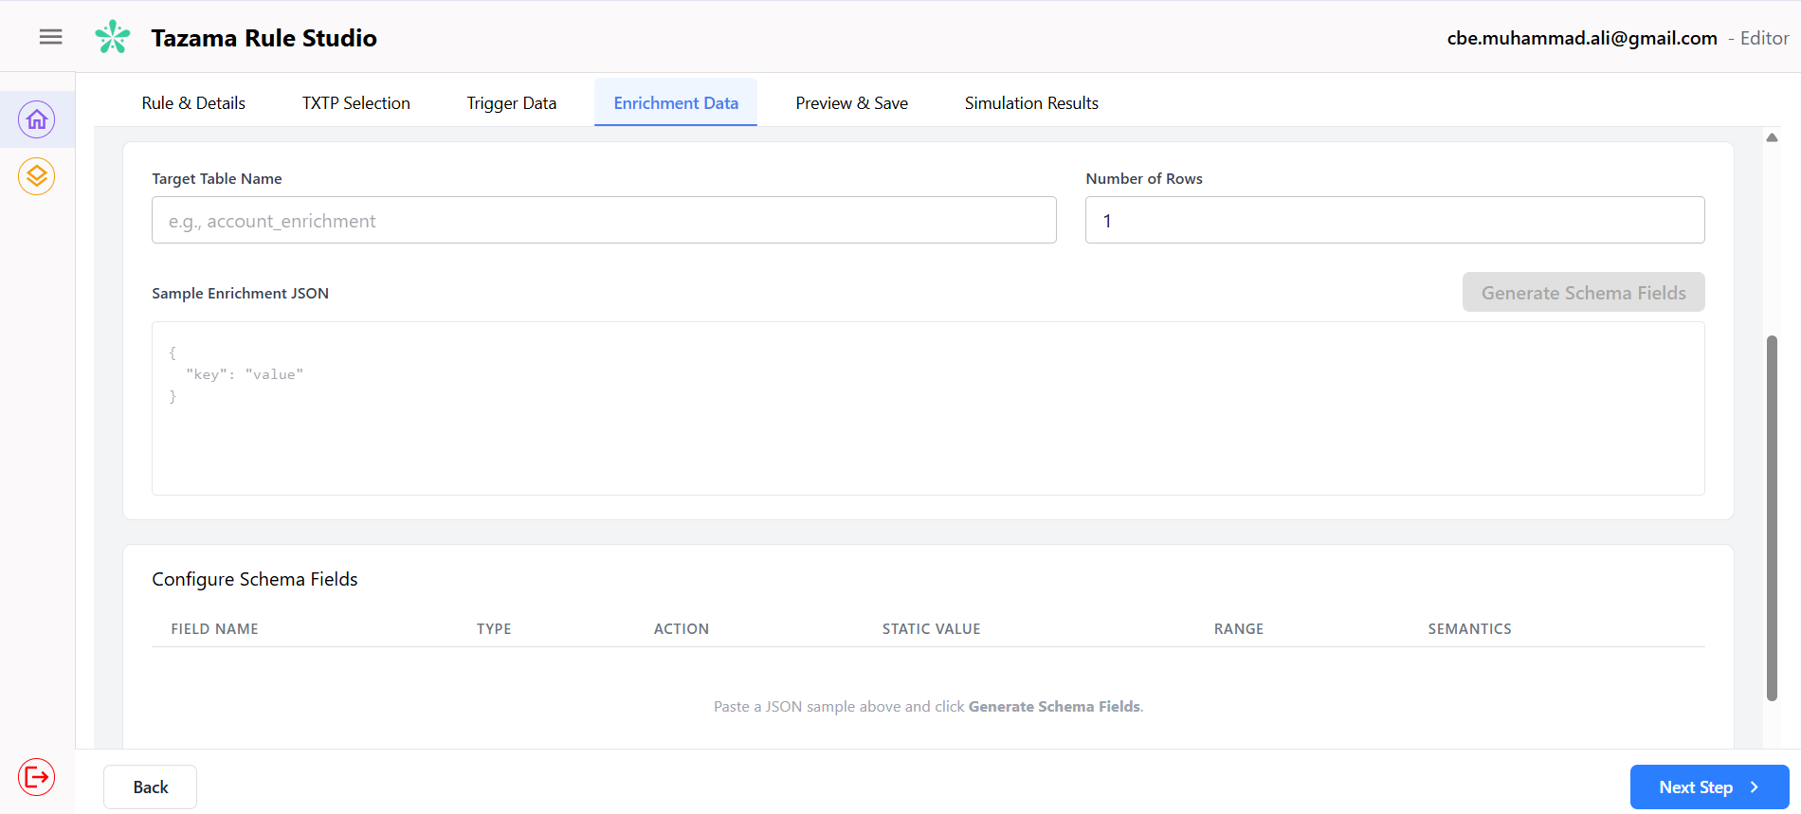
What is Enrichment Data? Enrichment data is reference information and is looked up by certain rules during evaluation. Unlike context data, which is transaction history, enrichment data is static reference data — for example, a sanctions list, an AML watchlist, or an account balance table. When a rule that relies on this data runs in the sandbox, it needs that reference table to exist and contain valid records, otherwise it cannot complete its evaluation correctly.

Adding an Enrichment Record
- Enter the name of the reference table in the Target Table Name field. This must be a valid JSON object that has the correct field names and structure that the rule processor expects to look up during execution.
Important: The target table name must match exactly the table name that the rule processor is configured to query. If the name does not match, the rule processor will not find the enrichment data during the simulation run and will produce incorrect results or fail.
- Enter the number of rows you want to generate in the Number of Rows field.
- In the Sample Enrichment JSON field, paste a JSON object that represents the structure of a record in that table. This does not need to be a real record from production — it can be any JSON that contains the correct field names and data types that the rule processor expects. For example, if the rule checks a name field against a sanctions table, your JSON should include a name field.
- Click Generate Schema Fields. The system will parse your JSON and populate the Configure Schema Fields table below with the fields it has extracted.

Configuring Schema Fields
The Configure Schema Fields table lists the fields extracted from your Sample Enrichment JSON. For each field you can:
- Set the Type — select the correct data type for the field from the dropdown. Available types are String, Number, Boolean, Date, and UUID. Make sure the type matches what the rule processor expects for that field.
- Set the Action — this works in the same way as the field configuration in Steps 2 and 3. Select how the field value should be populated: Sample Value, Set Static Value, Use Range, Skip Field, or Random with optional Semantics.
- Once you have configured the fields, click Save Record. The record will appear in the Enrichment Records section at the top of the page, showing the table name, the number of rows, and the field configuration.
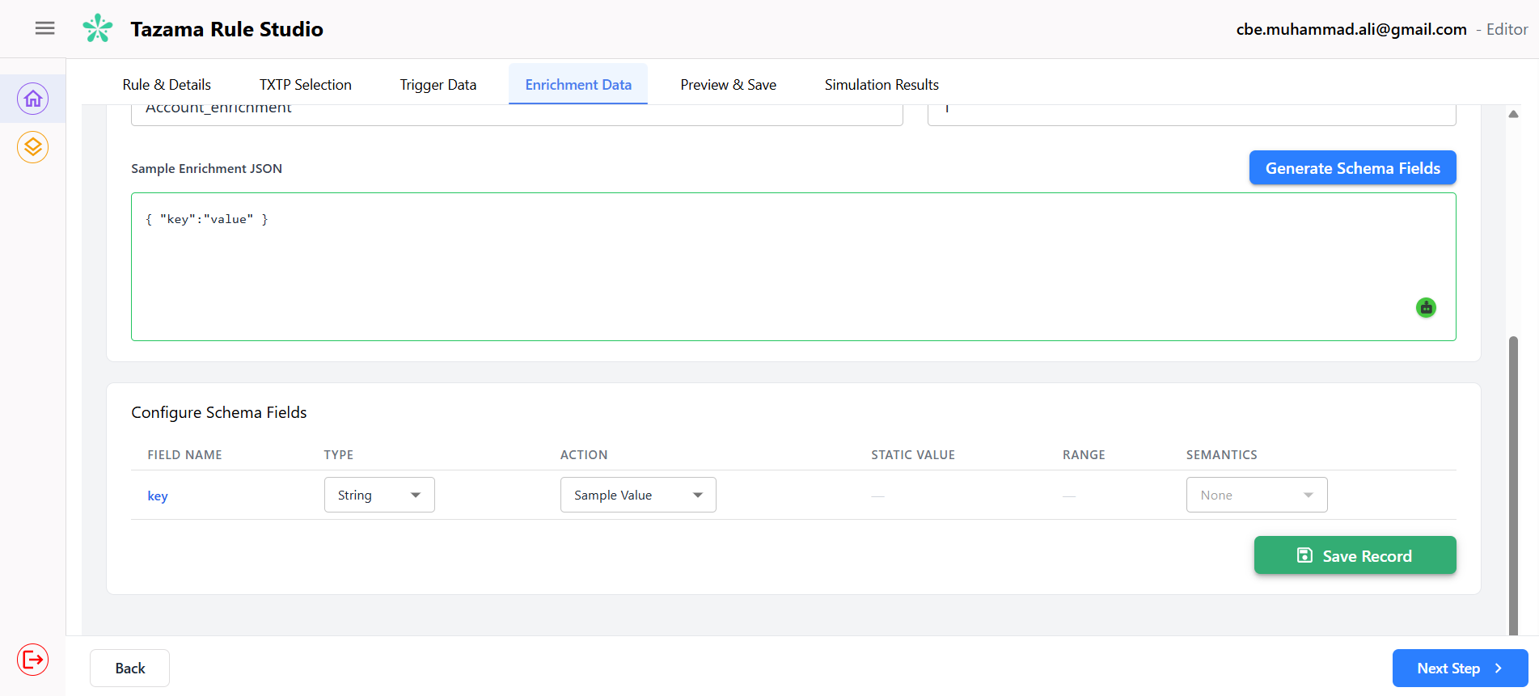
- You can add more enrichment records if your rule requires lookups against multiple reference tables. Repeat the steps above for each additional table.
- To delete a saved enrichment record, click the delete icon on the right side of the record in the Enrichment Records section.
- Once all required enrichment records have been added, click Next Step to proceed to Step 5.
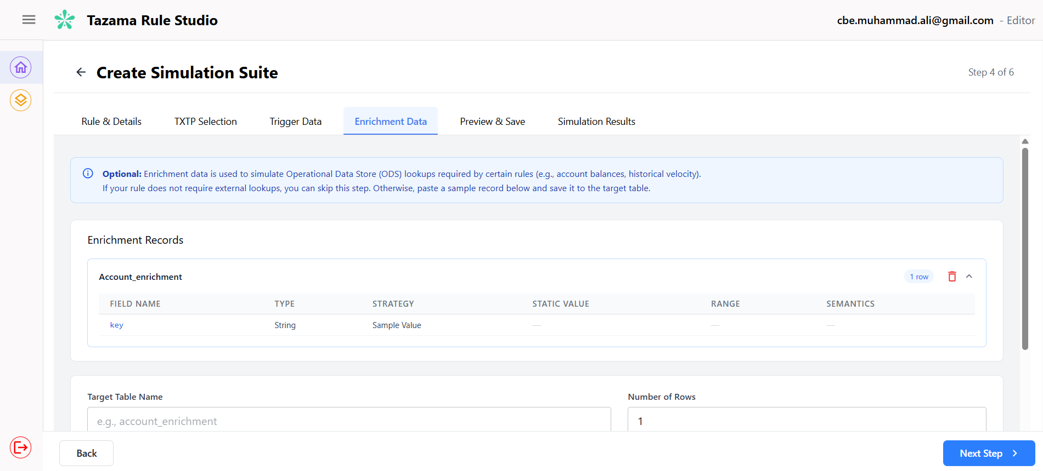

Preview and Save
This step gives you a complete overview of everything you have configured across the previous four steps before you run the simulation. No further configuration is required here — this is a review screen only.
At the top of the screen, three summary tiles display the total record counts for your dataset:
- Context Records — the total number of historical transaction records that will be loaded into the sandbox.
- Trigger Records — the number of trigger transactions that will be submitted to the rule processor.
- Enrichment Records — the number of enrichment reference records that will be loaded into the sandbox. This will show 0 if you skipped Step 4.
Below the tiles, the Simulation Summary panel shows the key details of your simulation suite:
- Suite Name — the name you gave this suite in Step 1.
- Associated Rule — the rule processor this suite will test.
- TXTPs — the transaction payload type and version selected in Step 1.
- Iteration Number — the version of this simulation run. For a newly created suite this will show as v1 (New), indicating this is the first iteration.
- Enrichment Table — the name of the enrichment table configured in Step 4, if applicable.
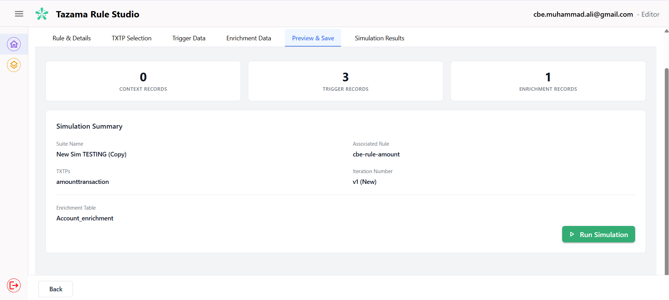
Your simulation suite has already been saved at this point. You do not need to perform any additional save action. The suite is stored in the system with a status of Draft, meaning the configuration is complete and persisted but no simulation has been executed yet. You can leave this screen and return to run the simulation later — your suite will be available in the Message Sampler dashboard.

Simulation Results
When you click Run Simulation on the Preview & Save screen, the system automatically executes the rule processor against your configured dataset, and brings you to the Simulation Results tab. You will see a loading indicator with the message Running simulation... Please wait while we fetch your results while this is in progress.

Reading the Results
Once the simulation completes, four summary tiles are displayed at the top of the screen:
- Total Runs — the total number of times this simulation suite has been executed, including the current run.
- Successful — the number of runs that completed without errors.
- Failed — the number of runs that did not complete due to an error.
- Total Triggers — the number of trigger transactions in which the rule processor's result band breached the configured threshold.

The Simulation History Table
Below the summary tiles, the Simulation History section lists each run of this suite. Each run is labelled with a run number, the associated rule, and the rule version. The overall status of the run — Success or Failed — is displayed on the right.
Expanding a run reveals the results for each trigger transaction that was evaluated. The results table contains the following columns:
- ID — a unique identifier for this result record.
- Trigger ID — the identifier of the trigger transaction that was submitted to the rule processor.
- Sub-Rule Ref — a reference to the specific sub-rule within the rule configuration that was applied during evaluation.
- Independent Variable — the numerical value calculated by the rule processor for this trigger transaction. This is the primary output you are validating.
- Payload — click the View button to inspect the full raw JSON payload of the trigger transaction that was evaluated by the rule processor.
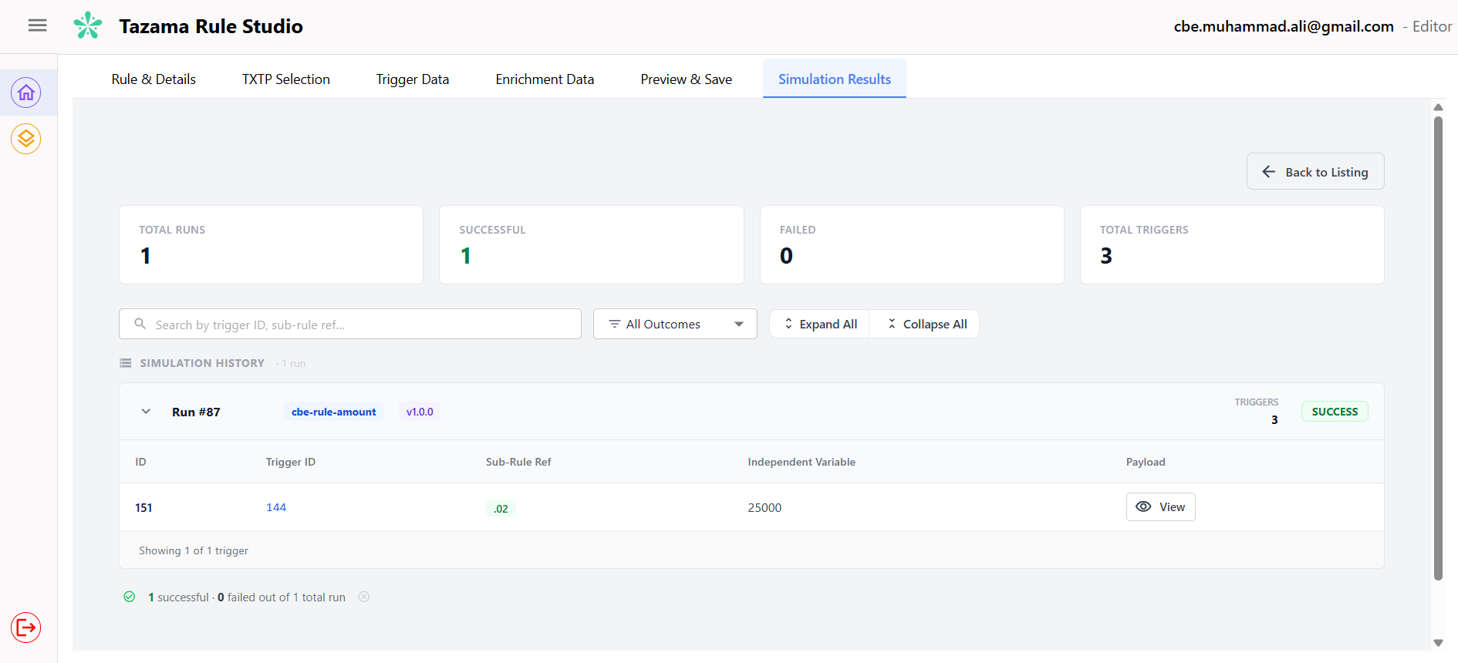

Working with Multiple Runs
If you have run the same simulation suite more than once, all runs are listed in the Simulation History section. You can use the Expand All and Collapse All buttons to manage the view when multiple runs are present. Use the All Outcomes filter dropdown to narrow the results by outcome, and use the search bar to find a specific result by Trigger ID or Sub-Rule Ref.

Appendices

Closing Note
The Simulation Module exists to give rule developers and testers a controlled, repeatable environment to verify that a rule behaves correctly before it is used in a live system. The value of that verification depends entirely on the quality of the dataset you build — a well-shaped synthetic dataset that exercises every decision branch of the rule will catch problems early. A poorly configured one will produce results that appear correct but miss edge cases that only surface later.
A few principles to carry into every simulation:
- Know your rule before you configure your data. The Simulation Module does not tell you what your rule should produce — it tells you what it does produce. The gap between those two things is what you are looking for. You cannot find that gap without a clear understanding of the rule's intended behavior going in.
- Be deliberate about field configuration. Every field you set to Use Sample Value is a field you are not controlling. For fields that directly influence the rule's logic, always make an explicit choice — static value, range, or a semantically appropriate random value. Leaving critical fields to defaults is the most common source of misleading results.
- Treat each saved suite as a reusable asset. Once a simulation suite has been configured and run successfully, it represents a verified test scenario. Keep it, name it clearly, and use it again when the rule is modified. Regression testing is only meaningful if you are running the same dataset against the changed rule — not a newly generated one.
- When results are unexpected, check the dataset first. Before concluding that a rule is broken, verify that the context data, trigger configuration, and enrichment records are correctly set up. Most unexpected results trace back to a misconfigured field rather than a rule defect.

Support and Escalation
For technical issues, access problems, or questions about system configuration, contact your designated Tazama Rule Studio system administrator.
For questions about what a specific rule is expected to produce, or how to shape a dataset to test a particular scenario, consult the rule developer responsible for that rule. The Simulation Module is a testing environment — questions about rule design and expected outputs are best answered by the person who built the rule.

Glossary
The following terms are used throughout this manual.
Simulation Suite — a named container that holds a synthetic test dataset and its configuration. It is associated with a specific rule and TXTP, and can be saved and reused across multiple simulation runs.
TXTP (Transaction Type Payload) — the message format that a rule processor expects to receive. Different rules operate on different transaction types. Selecting the correct TXTP ensures that the synthetic data generated is structured in a format the rule processor can read.
Context Data — the historical transaction records loaded into the sandbox before the simulation runs. The rule processor looks back at this data when evaluating the trigger transaction. Context data represents prior activity between the parties involved in the trigger transaction.
Trigger Data — the incoming transaction submitted to the rule processor during the simulation. This is the transaction the rule actually evaluates against the context data. There is typically one trigger transaction per test scenario.
Enrichment Data — static reference data loaded into the sandbox for rules that require external lookups during evaluation. Examples include sanctions lists, AML watchlists, or account balance tables. This is an optional step and only applies to rules that require it.
Field Override — a field-level instruction that tells the system how to populate a specific field in the trigger message. Field overrides allow you to control the exact value, range, or type of data submitted to the rule processor.
Independent Variable — the numerical value calculated by the rule processor for a given trigger transaction. This is the primary output validated in a simulation run. An incorrect independent variable means the rule is not producing the right output for the scenario tested.
Result Band — a human-readable classification assigned to the independent variable — for example, good, neutral, bad, or error. The result band is a display-layer label for analysts and does not influence fraud prediction scoring.
Iteration — a single saved version of a simulation run for a given suite. Each time you run a simulation, a new iteration is recorded. Iterations allow you to compare results across multiple runs of the same suite.
Ephemeral Environment — the temporary infrastructure spun up automatically by the system when a simulation is run. It exists only for the duration of the simulation and is destroyed once results are available. Your dataset and suite configuration are preserved — only the runtime environment is removed.
Linked Transaction Pair — a pairing of a pacs.008 credit transfer message with its corresponding pacs.002 payment status message, linked by a shared identifier such as the End-to-End ID. Some rules require this linkage in the context data to function correctly.
Sub-Rule Ref — a reference to the specific sub-rule within the rule configuration that was applied when evaluating a trigger transaction. Visible in the Simulation Results table.

